SANKRAIL ANIL BISWAS SMRITI MAHAVIDYALAYA
Affiliated to Vidyasagar University
Accredited by NAAC
AT & P.O- KULTIKRI, DIST- JHARGRAM, PIN-721135 (W.B.)

Memo No....................................... Date: 19/09/2020

Notice
All the teachers are hereby informed to provide their valid email id for VU Exam related issues within 21.09.2020 via<sankrailabs45@gmail.com> positively.

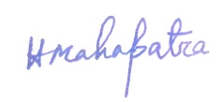
Teacher-in-Charge
